Advisory report

Jenny Doan

Vlad Roşioru

1-6-2023

Summary 3

Research question 3

Results 3

Advice 3

Introduction 3

Client, assignment and purpose 3

Who is the client? 3

What is the assigment? 3

What is the goal of the assigment? 4

Research 4

Research methods 4

Literature study 4

Design 4

Research 4

Prototyping and testing 4

Technology 5

SIMAC's side 5

Proof-of-concepts 5

Results 6

User testing 6

Conclusion 6

Design 6

Technology 6

# **Summary**

## Research question

During our industry project we worked with SIMAC IT NL. The problem that the company wanted to solve was stimulating recognition within its workforce. Our clients noticed the power that positive validation can have in motivating people. However, the fact remains that in most companies, good results can often go unnoticed. On the other hand, negative performance will receive a lot more attention

This led to the following goal: what can SIMAC do to accentuate the positive within its workforce and stimulate recognition?

## Results

Based on our research, we decided to design a narrowcasting system where employees’ accomplishments could be displayed. This would let their coworkers see what they have done and encourage them to acknowledge each other’s achievements within their team.

Since this would be transmitted through SIMAC’s TV screens, there were a few things we had to take into consideration. A great focus in our work was capturing people’s attention and making designs that worked well when seen on a large screen, from a distance. This translated into the use of high contrast and animations.

## Advice

# **Introduction**

## Client, assignment and purpose

### Who is the client?

Our client for this project was SIMAC IT NL, a company under the umbrella of the SIMAC holding. SIMAC is a family-owned organization that focuses on providing IT solutions for companies of all different sizes. We have been assigned two stakeholders from SIMAC, Nico van der Steen and Jan van der Sanden.

### What is the assigment?

The initial assignment of SIMAC was to create a system in which employees of Simac send compliments to each other. This was brought up to combat the general company mindset, wherein employees are only spoken out on the negatives instead of the positives.

However, based on research, we found out that compliments don't have much of an effect if the employees aren't motivated first. We spoke with SIMAC about our findings, and to instead focus on creating a system to stimulate more motivation in the workforce. To still go with Simac's goal of the initial assignment, we choose to redirect our focus on creating a system to stimulate more recognition for employees in the workforce in increase motivation.

### What is the goal of the assigment?

The goal is to combat the general company mindset, wherein employees are only spoken out on what goes wrong, and instead speak more about the positives to build a more positive workforce. Speaking only about the negatives can lead to strained relationships and distrust among employees. By accentuating the positive and redirecting the negatives, productivity is increased which leads to better work relationships and more trust. By having the positives also recognized by the rest of the workforce, employees become more intrinsically motivated to work further.

# **Research**

## Research methods

The following research methods from the [CMD Methods Pack](https://cmdmethods.nl/) were used:

*Library:* Expert interview, Literature study

*Field:* Observation, Survey

*Lab:* A/B testing, Usability testing

*Showroom:* Peer review, Pitch

*Workshop:* Ideation, Proof of concept, Prototyping

*Stepping stones:* Concept

* To add more?

### Literature study

### Design

#### Research

To make our designs, we started by researching several relevant topics. Due to the medium we would use, the focus of this research was more towards visual design than user interaction. For this we researched guidelines that are currently in use, such as Google’s Material Design or Apple’s Human Interface Guidelines, as well as principles used in graphic design. We also investigated design guidelines for TV screens and the uses of graphic design in advertising. Our findings were then combined with SIMAC’s own style guide for a consistent look.

To determine the content of the screens, research was done into narrowcasting and workplace recognition, that would determine how these two could be combined in an office.

#### Prototyping and testing

After determining the content of the narrowcasting system, we made prototypes of the narrowcasting screens in Figma to get an idea of what they would look like. After finishing the screens, we were able to use them to conduct user testing.

The main goal of the testing was to know if our product is in line with the main goal: stimulating recognition. Also important was how effectively the designs could attract viewers’ attention, and how likely they would be to look at them if they saw them at work.

### Technology

#### SIMAC's side

For the technological side of narrowcasting, an interview was conducted to the manager of the broad- and narrowcasting of SIMAC, Erwin van de Schoot. Questions regarding their use of narrowcasting were asked, to determine if they already have screens that further employee recognition and what technologies are used.

From the answers, it came out that SIMAC only has one screen for employee recognition: anniversaries for employees who have worked for a certain number of years (12.5, 25 years). From this, we definitely see that there's more potential for more screens for recognition to be showcased for more different scenarios.

For the technological aspects, SIMAC uses the external service for the narrowcasting of GISB Audiovisueel, which in turn uses LeftClick for the implementation. The backend is then utilized with a FMIS-system (Facilitair Management Informatie Systeem) from Facilitator for managing the organizations. This helps us understand the process of narrowcasting and confirm the information we have already gathered before.

From this, we can design our narrowcasting for concepting correctly according to this way of implementation.

#### Proof-of-concepts

To demonstrate our findings in practice, we made proof-of-concepts by programming different kinds of screens in HTML, CSS and JavaScript. The screens developed are based on templates that are commonly found in narrowcasting systems like of SIMAC:

* Basic content display
* Content filtering
* API
* Animations
* Real time content updates
* Content scheduling

In the screens, data about the employees are shown regarding various topics like achievements, birthdays, etc. Because SIMAC’s narrowcasting only has one screen for recognition, new data that are specifically about the employees may have to be added if the screens are automatically updated in real-time.

## Results

### User testing

To validate our designs for the narrowcasting screens, we have done user testing to see if they convey a sense of recognition and appreciation like intended. The tests are answered by people who have never seen the designs before, so the answers are completely based on first impressions. This helps to get us a more non-biased view of it.

For the testing, these are the screens that we used to get feedback.

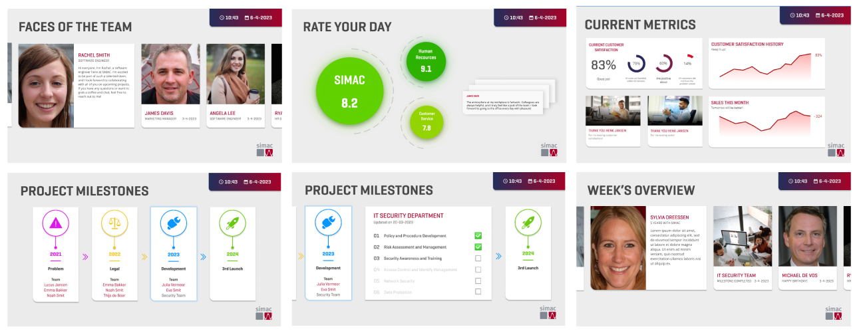

From the answers that we got and collected, we found out that the testers do feel that the screens convey a sense of recognition and appreciation and liked the overall designs of it. For some screens, some participants found difficulty in finding either appreciation of recognition, but never both of them. The overall feedback for the designs is that the purpose of the content could be more obvious.

Based on the answers, we have adjusted several aspects of the design to further improve conveying the message of the screens.

# **Conclusion**

## Design

The design of the narrowcasting system follows the guidelines in SIMAC’s style guide. Attention will need to be paid to the medium of the project when expending it. This includes taking into account guidelines for TV based apps: larger content to be viewed from a larger distance, avoiding large paragraphs, using larger font sizes. The format of a narrowcasting system also comes with its own design elements to be followed: use of elements such as animation and color contrast to attract attention, short titles that can quickly catch the attention of viewers.

## Technology

To stimulate more employee recognition, it is recommended to input more templates about the employees into the narrowcasting system. The extra screen should show data that is about the employees, like names, positions, etc. If needed, some extra employee data should be added to the database to display it on the screens for real-time updates.